**PROJECT REPORT**

**ATTENDANCE MANAGEMENT SYSTEM**



*Submitted to*

*Dr Aman Sharma*

*Dept. of Computer Science and Engineering*

*JUIT*

By

Shivam Singh Negi

Abhishek Sharma

**Jaypee University Of Information and technology**

**Certificate**

This is to certify that the project titled “ATTENDANCE MANAGEMENT SYSTEM” has been submitted to the Department of Computer Science and Engineering,Jaypee University Of Technology by following students.

**Student Name (With Roll No)**

191260 SHIVAM SINGH NEGI

**Declaration**

We,hereby declare that the discussion entitled “ATTENDANCE MANAGEMENT SYSTEM” being submitted by us and have not been submitted anywhere else.

We will be solely responsible if any kind of plagiarism is found.

Date:

**ACKNOWLEDGMENT**

We like to share our sincere gratitude to all those who helped us in completion of this project. During the project we faced several difficulties due to lack of our knowledge and experience but these people help us to get over from all the challenges and final compilation of our idea to a shaped sculpture.

We would like to thank Dr Aman Sharma for his governance and guidance, because of which our whole team was able to learn the minute aspects of project work.

I would like to thank our friend Kartik Ganotra who helped us to resolved some important issues .

In the end I would like to thank Dr Aman Sharma for providing us this opportunity to learn from his experiences.

All of us are thankful to all the Faculty and staff members of the dept.

for their help support towards this project.

We are also thankful to our whole class and most of all our parents who have inspired us to face all the challenges and win all the hurdles in life.

Thank you All

**Table of content**

|  |  |  |
| --- | --- | --- |
| **S. NO** | **TITLE** | **PAGE NO.** |
| **1** | **ABSTRACT** |  |
| **2** | **INTRODUCTION** |  |
| **2.1** | **Literature Survey** |  |
| **2.2** | **Developed  Approach/Algorithm** |  |
| **3** | **Results and Discussion** |  |
| **4** | **Conclusion and Future Work** |  |
|  |  |  |

**ABSTRACT**

The conventional method of making a register or manually recording each individuals attendance is quite hectic. Using modern programming tool Python and its extended functionalities the following system is developed.

We have added functionalities like speech recoginization, adding extra data like entry, exit time, duration of stay and visual represenation of data.

The system is voice controlled and can identify multiple faces at same time too in real time.

This system response to various predefined voice command like “good morning ”, “good night” to manupilate the attendance sheet like marking present , entry time ,exit time and also show piechart of attendaance frequency accordingly.

The main motivation for developing this system is to replace the conventional ways to marking attendance with a new and efficent ways.

**1.Introduction**

Facial recognition is a biometric software application capable of uniquely identifying or verifying a person by comparing and analyzing patterns based on the person’s facial contours. The technology is mostly used for security purposes, though there is increasing interest in other areas of use. Facial recognition technology has received significant attention as it has the potential for a wide range of application related to law enforcement as well as other enterprises.

The conventional way of marking one's attendance at an organization includes marking your entry in a register ,using biometric signature like fingerprints , or swiping a card.

But all these convenctional method have their flaws like an proxy could be marked in register, your id card could be stolen and used to mark unwanted entry, your fingerprints are replicated.

One of the alternative to solve these problems is that we can use a face as an individual's identity i.e. we can use face recogonization .

The system is developed for deploying an easy and a secure way of taking down attendance.

This system first captures several image of the employee for future refrencess and stores the information into database along with their name as a lable. The system then stores the image by mapping it into a face coordinate structure.

Next time whenever the registered person enters the permisses say "good morning" in the system ,the system will marks his/her entry time and name. At the time of exit when the person says “good night” or “good afternoon" then the system will again check the database and will mark the person’s exit time and finally mark his present. This system also allows the employee to view their number of presents /absent in the form of a piechart and also show them their attendance record.

The main motivation for this project was the slow and nefficient traditional manual attendance system. So, why not make it automated fast and much efficiently.

LITERARY SURVEY

Releated work-

An automatic attendance management system is a good and active topic for many aurthors to work and improve upon. Till now new improvement are done in this topic. Some of the developers who contributed to this topic includes are-

1)K.P. Zaeharia used face recogonization as a base to built this system/model using PCA .

2) Ajinkya Patil with their fellows in [5] proposed a

face recognition approach for attendance marking using

Viola jones algorithm, Haar cascades are used to detect

faces in images and recognition performs through Eigen

face method.

2) Ajinkya Patil with their fellows in [5] proposed a

face recognition approach for attendance marking using

Viola jones algorithm, Haar cascades are used to detect

faces in images and recognition performs through Eigen

face method

Ajinkya Patil with their fellows in [5] proposed a

face recognition approach for attendance marking using

Viola jones algorithm, Haar cascades are used to detect

faces in images and recognition performs through Eigen

face method

Ajinkya Patil with their fellows in [5] proposed a

face recognition approach for attendance marking using

Viola jones algorithm, Haar cascades are used to detect

faces in images and recognition performs through Eigen

face method

Ajinkya Patil with their fellows in [5] proposed a

face recognition approach for attendance marking using

Viola jones algorithm, Haar cascades are used to detect

faces in images and recognition performs through Eigen

face method

Ajinkya Patil with their fellows in [5] proposed a

face recognition approach for attendance marking using

Viola jones algorithm, Haar cascades are used to detect

faces in images and recognition performs through Eigen

face method

2) Ajinkya Patil with their fellows in [5] proposed a

face recognition approach for attendance marking using

Viola jones algorithm, Haar cascades are used to detect

faces in images and recognition performs through Eigen

face method.

2)Ajinkya Patil with his team proposed attendance management model which uses Viola jones algorithm, Haar cascades algorithm to detect the faces and identify them using Eigen method. (The Eigen method /algorithm

Extract extract information from the image by using multiple images of the person for variation ).

3) MuthuKalyani.K, VeeraMuthu. Using PCA algorithm they designed an Efficient Attendance Management, providing accuracy up to 83% but slight changes in the light conditon causes decrease in the system’s performance . Then they used eigen face approach for marking face recognition attendance. Also they mention comparison of different face recognition algorithm in their paper.

Develop algorithm-

To impliment face recognization we have used haar cascade algorithm.

For proper functionality we have created several modules for purposes-

1)To add a new user to the database.

2)To marks the entry of the user in the main attendance list(csv format).

3)To marks the exit of the user along with updating their duration of stay and marking them finally present.

4)To represent the attendance record of the user.

5) To implement voice recogonization.

6)The main.py file which combines all the module together.

MAIN PYTHON FILE

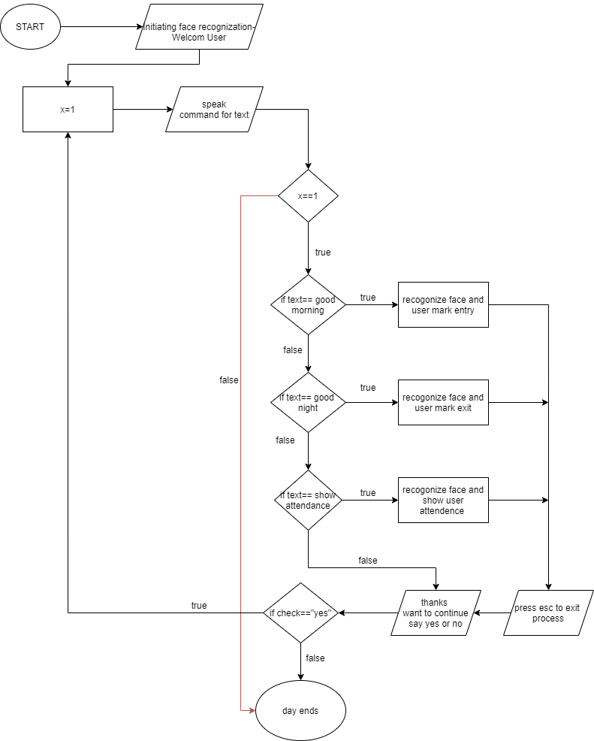

The function of Main.py is to Compile and execute all the created module and functions in a systematic way to provide the user an output.

To import all the created function we must have to import their modules

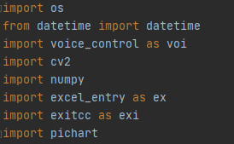

To detect the face in the object detected we will use haarcascade algorithm.



Now this code segment will help you to map the Images with their user names.

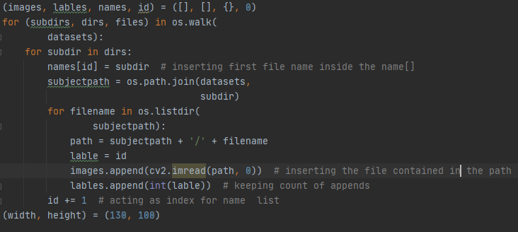

Here, OS.walk() generate the file names in a directory tree by walking the tree either top-down or bottom-up. For each directory in the tree rooted at directory top (including top itself), it yields a 3-tuple (dirpath, dirnames, filenames)

The os.listdir(subjectpath) is used to extract all the files and directorys specified in the path shared as parameter

//this is to be specified

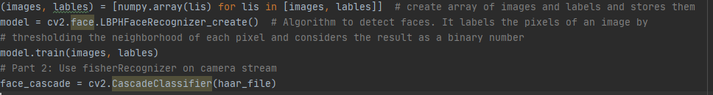

To grab the system date and time.

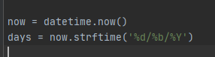

Now All the functionalities are include in the while loop

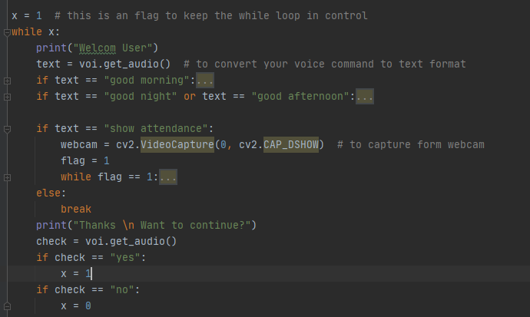

Initially on each voice commands listed in the if condition ,using the camera attached it will identify your face by capturing some still images of the user in real time and then it will find for a match for the image in the dataset and will attached a lable /user name to the captured image .

Now , this lable/user name will pass to the name variable and this passed name is retained and is used for different functionality on different voice commands

The code snipet for this –

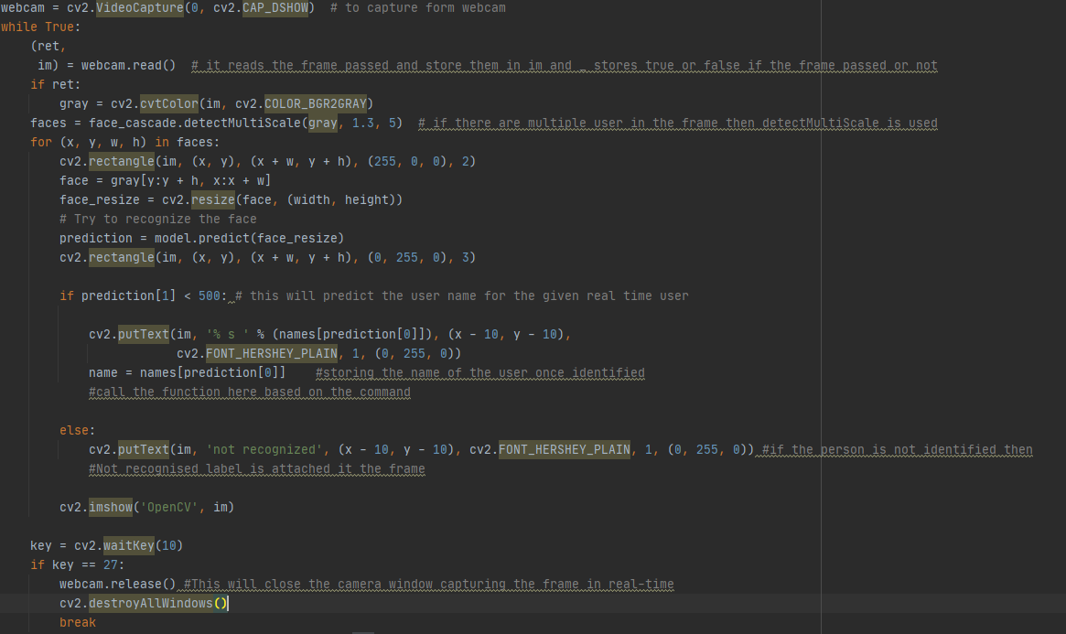

Entry control-

Now if the voice command passed is “good morning” then make_attendance_entry(days, name) function will be called.

The flow chart for the function is-

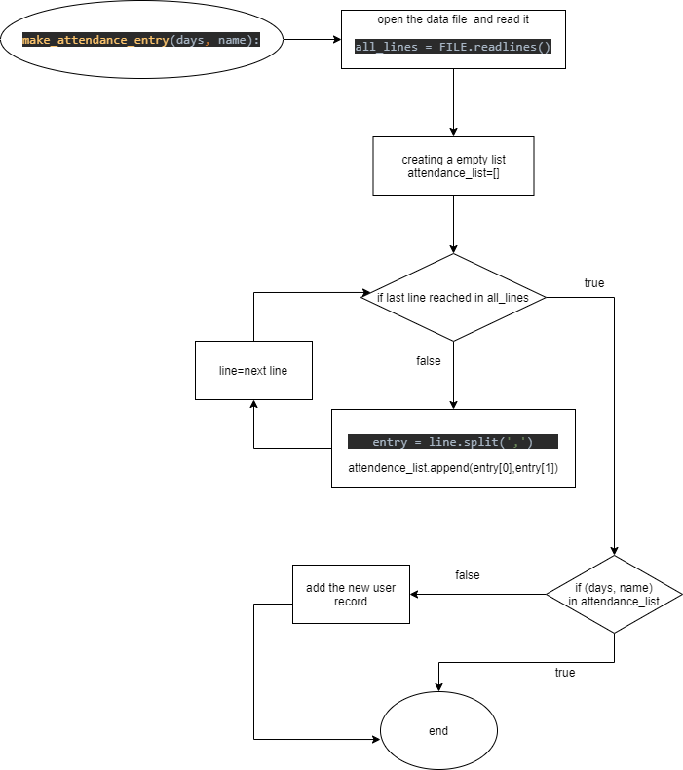

The code snipet for the function-

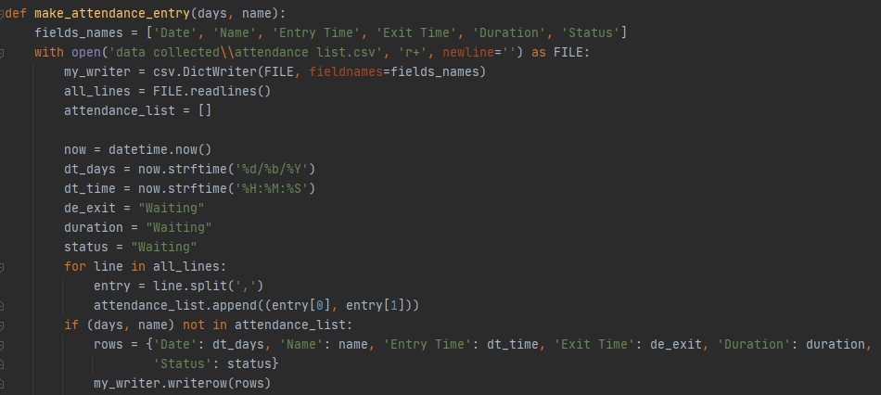

Exit control-

Now if the voice command passed is “good night” or “good afternoon” then make_attendance_exit(days, name) function will be called.

The flow chart for the function is-

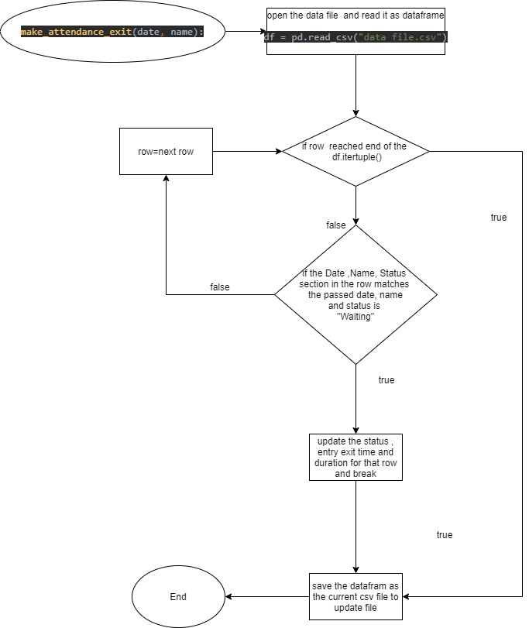

Code snipet for the function-

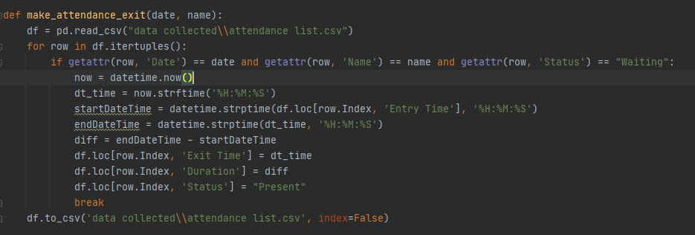

Here for data handling we have used pandas’s dataframe.

Pichart

Creating datasets

In this project we have to build our own dataset depending upon the type of organization(educational , workplace etc.)

The dataset can very from organization to organization.

So to create/ add an user to dataset we first take setup the algorithm for face detection that is haarcascade.xml

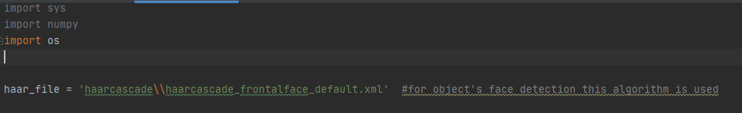

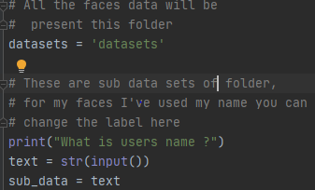

The input name will become the name of the subfolder that will contain the images of newly added user in the directory datasets.

This snipet will let will turn on the camera attached to capture the images of a users’s face and store them in the sub folder of the name provided above to the sub_data object in dataset directory .

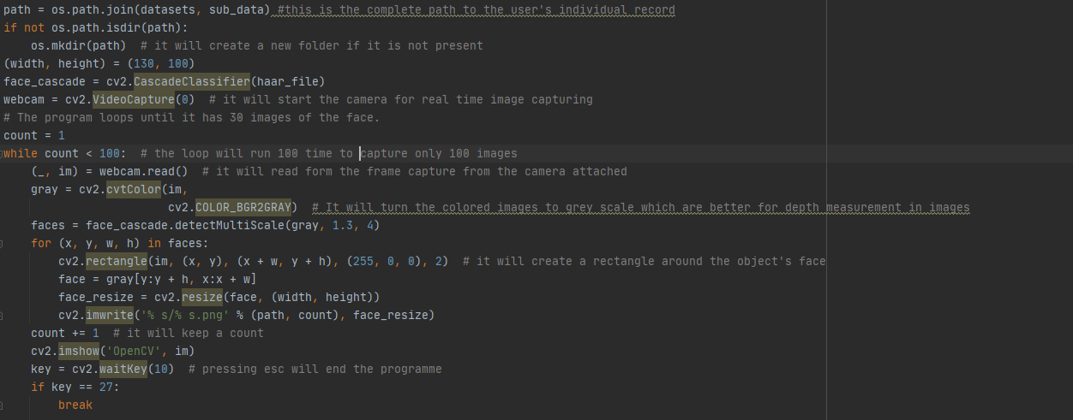

Results –

1)Initially the attendance list is empty- 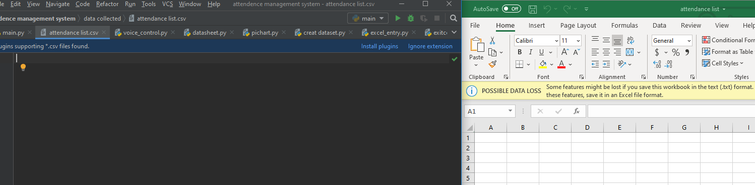

After running the system and passing “good morning” ( see the terminal) as a command-face is identified. Also the attendendance sheet is updated.

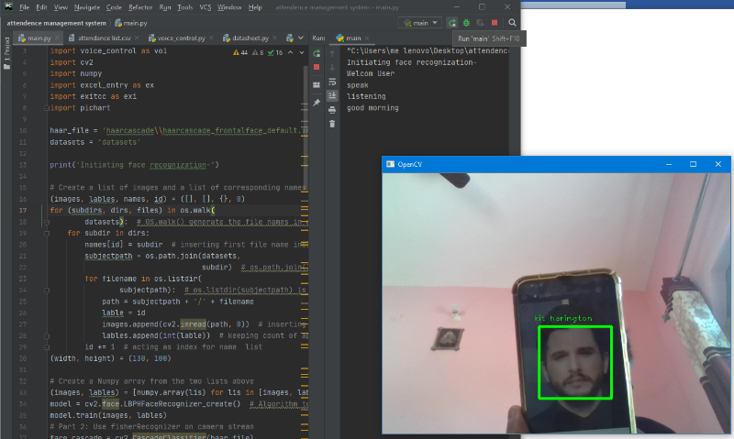

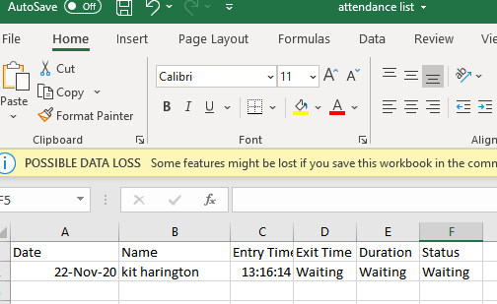

2)Then on saying yes to continue again speak the command “good night” or “good afternoon”-

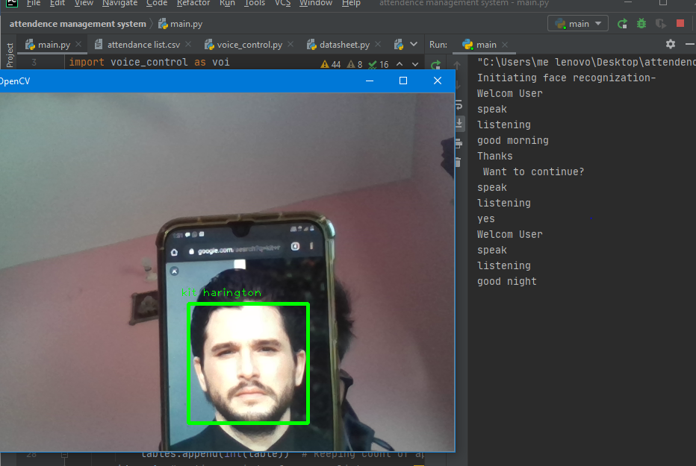

The exit time,duration, and status are updated.

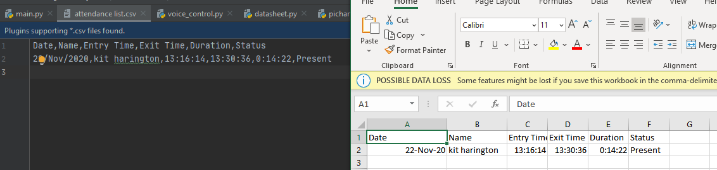

**3)**On saying “show attendance” your record as well as no.of present /absent piechart will be shown.

Let the attendance file’s record be- the output in the terminal and the piechart is shown

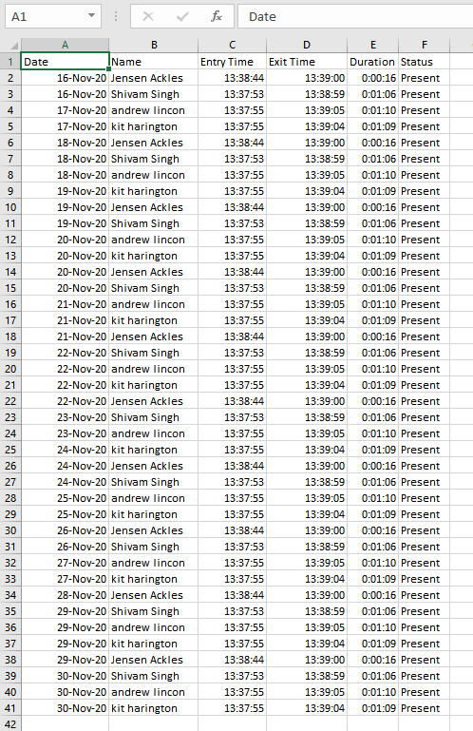

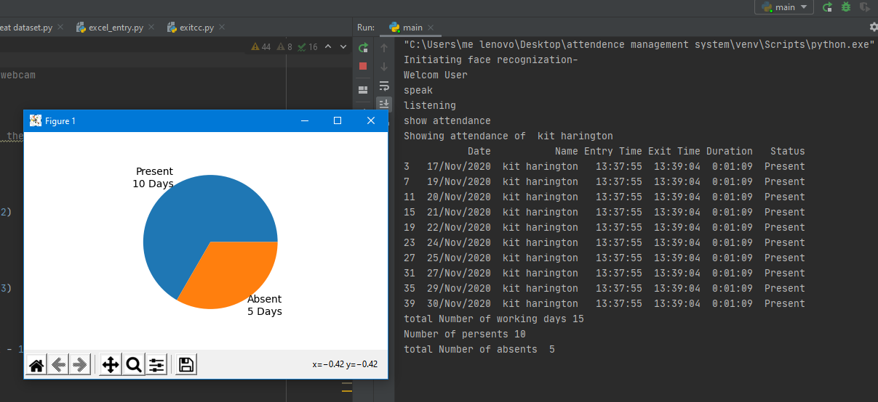

Conclusion-

This system uses internet (for running voice recognization api), webcam (for capturing the person’s image in real time). With an increase in the quality of webcam and speed of internet connectivity the efficency of the system also increases.

This system completes all its functionality and provides the required outputs. This system is also able to incoorporate any new features that the organization need.

Hence the aim/motivation to built an automated attendance management system is achieved this developed system which help to overcome some of the flaws of the convenctional ways of maintain attendance in an organization.